**Project**

Name of project: CASSANDRA - An IoT system for long-term monitoring and alerting vital heart problems

Competition Track: Planet NI

**Contact Information**

Name:  Phạm Khôi Nguyên

School:  International University – Vietnam National University (VNU)

Department:  Biomedical Engineering   Year:  2013 - 2017

Email: phamkhoinguyen1995@gmail.com       Mobile Phone: + (84) 914 118 896

Mailing Address:  Room 34, Binh Phu Apartment, Ward 10, District 6, Ho Chi Minh City

**Project Adviser**

Name:  Dr. Lê Quốc Trung

Title:  Lecturer of University                    Organization: International University – VNU

Email: lequoctrung@gmail.com             Mobile phone: + (84) 915 538 938

**Team Members**

1. Name:  Cù Gia Huy

Email:  [huycu17@gmail.com](mailto:huycu17@gmail.com)

Mobile phone:  + (84) 969 074 690

1. Name:  Nguyễn Thanh Trúc

Email:  [ngthanhtruc.iuetv@gmail.com](mailto:ngthanhtruc.iuetv@gmail.com)

Mobile phone:  + (84) 166 262 7929

**Project Paper**

1. **Abstract**

Cassandra is a complete Internet of Things system dedicated to provide long - term, instantaneous cardiac surveillance for remote healthcare, sport and clinic. The project consists of a chest - worn device that measures ECG signal, an intermediate device which can either be a smartphone or a stationary hub to stream data, an algorithm to detect heart problems and a management software. The team hopes to bring forward the era of homecare where patients at risk of CAD can get full access to hospital healthcare services while staying at home.

1. **Project Introduction**

**Problem**

For many decades, Cardiovascular Disease (CAD) is the leading cause of death during patients’ hospitalization across the globe. As reported by the World Health Organization (WHO), there was about 17.3 million people around the world died from CAD in 2008, representing 30% of all total cases of death globally. This number is expected to grow up to 23 million by 2030. Vietnam is also one the most susceptible countries to CAD. The World Heart Federation (WHF) estimates that the incidence of CAD in Vietnam in 2017 may reach 20%, ranking 4th in the world.

The most effective way to address CAD is focusing on preventive medicine, where the disease is diagnosed at an early stage and medication can be given to stop its progression. Among various types of diagnosis techniques, the Electrocardiogram signal (ECG) yields many superior advantages. For many decades, ECG has been considered as the gold standard for approving patients to the Heart Disease Department in almost hospitals around the world. The diagnosis is significantly cheaper and faster than imaging methods such as MRI, CT angiography or cardiac ultrasound while still retaining very high level of medical reliability. Moreover, the ECG device can be technically built into a very small, compact wearable that is suitable for point-of-care service or homecare solution.

**Innovations**

Appealingly, however, homecare ECG devices currently on sale still lack the ability to communicate directly with the doctor at local clinics or central hospitals. They also cannot perform long – term monitoring which is a crucial aspect in disease detection. Many startups have emerged to address this problem, however, they still lack a decent software that can automatically detect CAD. Taking a step further, Cassandra not only provides the hardware for ECG measurement and implement it diversely to fit into practical use, but also provides doctor with a software that could assist them to make better and faster diagnosis.

**How we use our NI packages**

Product simulation and prototyping is accomplished using National Instrument (NI) LabVIEW. We use the software package to develop the diagnosis algorithm and perform result validation. NI myRIO is developed into an intermediate device that receives data from ECG modules and perform disease detection.

**3. Design Methodology**

<Explain the process or phases of your project. You may include a flowchart or any  
materials that are relevant in explaining the process flow and its timelines. >

**4. Design Architecture**

<Explain the different system functions with diagrams, interface images, and so on.>

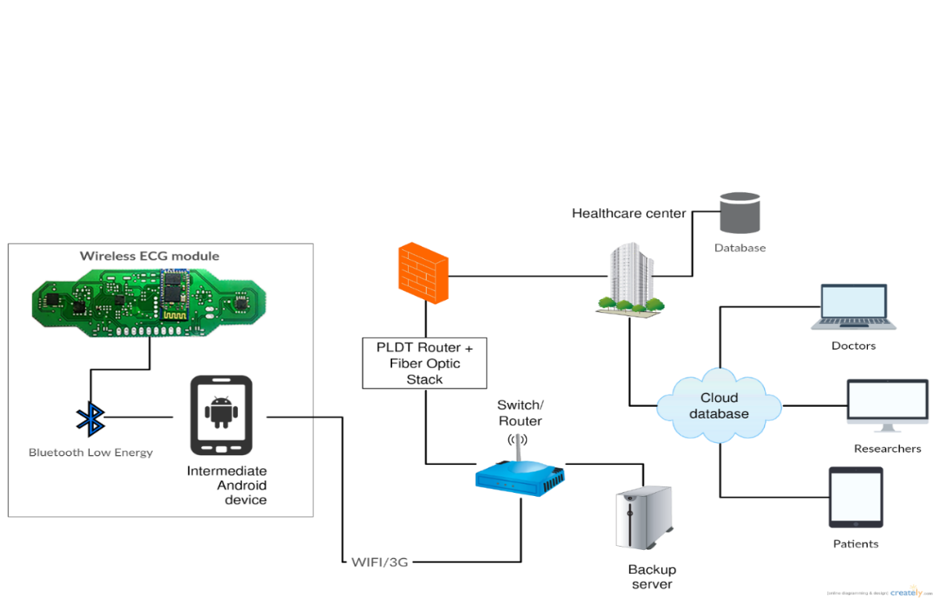

**Figure 5.** The complete system of our wireless and portable ECG monitoring device

1. Wireless ECG module: a compact wearable that acquires ECG signal on 4 crucial leads, including 3 limb leads (I, II, III) and 1 chest leads (V1) and transmit data via Bluetooth LE 4.0.

2. Intermediate devices: android, iOS smartphones or stationary hub developed with NI myRIO for receiving and streaming data to the cloud

3. Dedicated server: receive data package and perform disease detection.

4. Database: storing diagnosis result and data records

4. Management platform: website for doctors, patients and researchers to access data records

**5. Functional description**

<Include a more technical explanation that describes the functions of the system in  
your project and the interactions that can occur between the system and its actors  
(through the interfaces).>

1. Wireless ECG module

The module consists of three components: AD8232 Single Lead Heart Rate Monitor, Arduino Nano and HC-05 Bluetooth module.

The AD8232 Single Lead Heart Rate Monitor is a board used to capture the electrical signals of the heart with low cost. The board has the following pins

* SDN: Shutdown Control Input. Drive SDN low to enter the low power shutdown mode.
* LO+: Leads Off Comparator Output. In dc leads off detection mode, LO+ is high when the +IN electrode is disconnected, and it is low when connected.
* LO-: Leads Off Comparator Output. In dc leads off detection mode, LO− is high when the electrode to −IN is disconnected, and it is low when connected.
* OUTPUT: Operational Amplifier Output. The fully conditioned heart rate signal is present at this output. OUT can be connected to the input of an ADC.
* 3.3V: Power Supply Terminal.
* GND: Power Supply Ground.

Also on this board, there is a 3.5mm connector which receives signals from 3 electrodes: Right Arm (RA), Left Arm (LA), and Right Leg (RL). Additionally, there is an LED indicator light that will blink to the rhythm of a heartbeat [4].

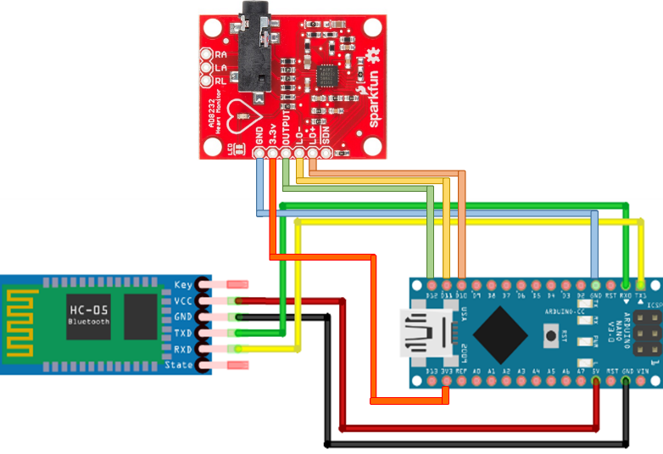

**Figure 7. Wiring network of wECG prototype**

The Table 1 show the connection between Arduino Nano and AD8232 module. Programming in Arduino use C language, in our system, one Analog pin of Arduino read the Output value of AD8232 and two digital pins read the output value of LO- and LO+, if LO- and LO+ outputs are high, the Arduino will return “!”.

Table 1. AD8232 and Arduino Nano connection

|  |  |  |
| --- | --- | --- |
| Board Label | Pin Function | Arduino Connection |
| GND | Ground | GND |
| 3.3v | 3.3v Power Supply | 3.3v |
| OUTPUT | Output Signal | A0 |
| LO- | Leads-off Detect - | 11 |
| LO+ | Leads-off Detect + | 10 |
| SDN | Shutdown | Not used |

HC-05 is a small, low cost, module using Bluetooth technology for exchanging data over short distances. Maximum range is approximately 10 Meters. Using Bluetooth make the system wireless, more portable and Heart Rate monitoring can be performed from distance, more conveniently.

1. Intermediate devices
2. Mobile application

Mobile application is built with the following technology:

* Ionic framework for creating cross platform application
* ngCordova JavaScript library for controlling mobile’s hardware, including a geolocation sensor and built in Bluetooth
* Chartis.js for creating graphical result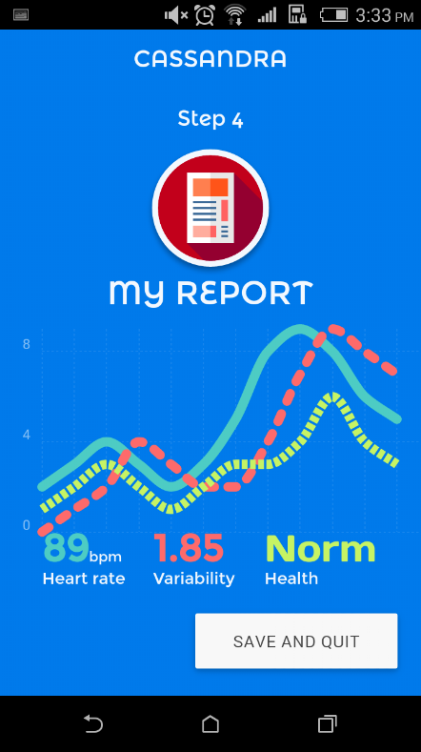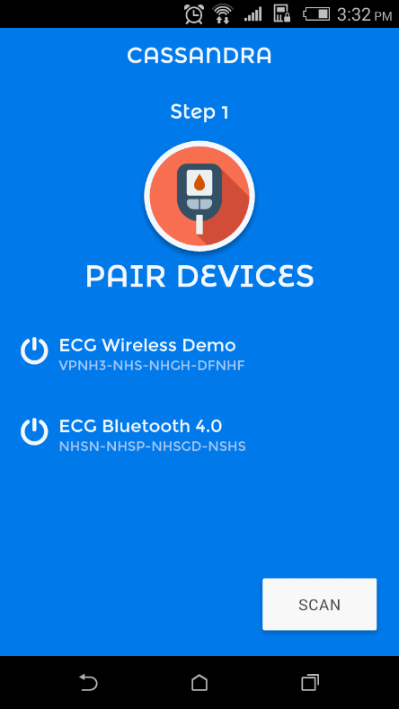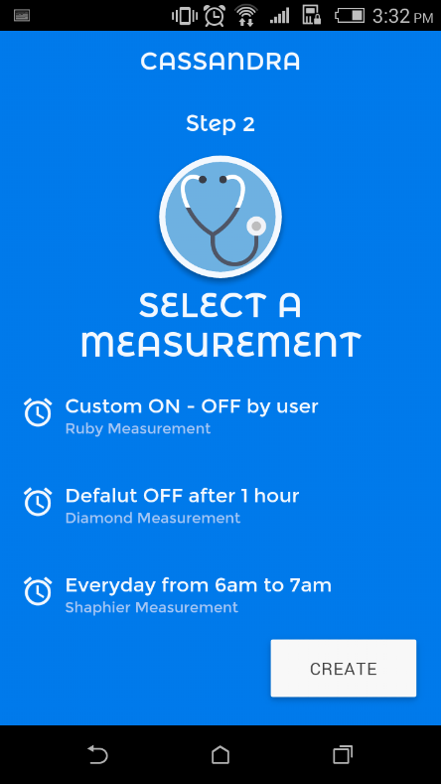

**Figure 4**. In order to use our application, user has to pair the smartphone with our ECG device, select a measurement type, complete the measuring process and then save the report to doctor

1. **Stationary hub for homecare**

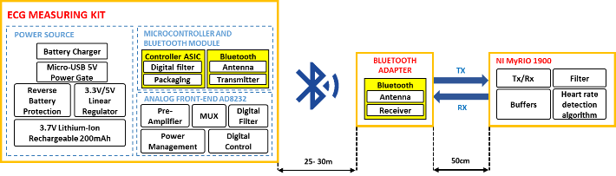

**Figure 6. Block diagram of the stationary hub and its interaction with the ECG module**

## Bluetooth adapter

Bluetooth adapter includes 2 Bluetooth HC-05 modules soldering on a breadboard and 2 34-pin connectors, which is well-fit with myRIO pin out. Bluetooth adapter plays role as wireless terminal receiver which receives data from ECG module and transmit to myRIO kit.

## NI myRIO kit

NI myRIO is an embedded hardware device, which is sufficient in signal processing. With built-in FPGA Zynq 7010, the kit is powerful enough to analyze wireless signal in real-time and process complex algorithms. In this project, myRIO kit is used as a homecare station, which able to communicate with wireless healthcare device via Bluetooth connection and acquire the vital signals. Those signals are processed and health status is displayed.

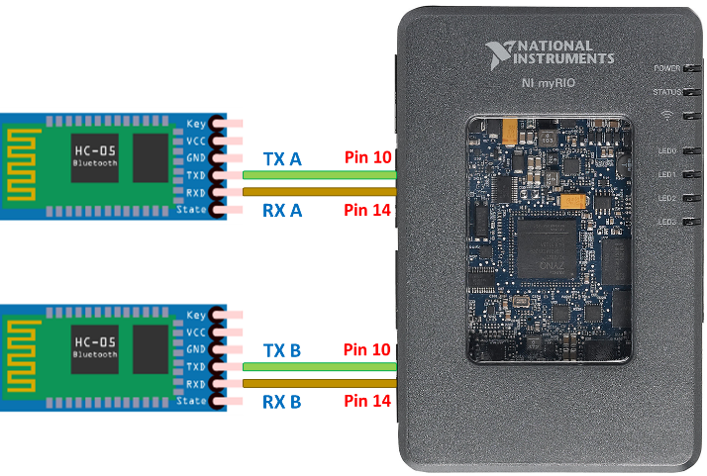

**Figure 8. Wiring network of the Data Hub**

Protecting the heart is crucial for every family. Cassandra system is the solution for cardiovascular homecare. This is a monitoring system that enables ECG recording data transmitted from home directly to the server in hospital. To fully operate, Cassandra contains 2 main components: a wireless ECG monitoring device (wECG) and a data hub. The wECG is designed as a small, lightweight, flexible patch to continuously record the heart electrical activity. The data is transmitted to the NI MyRIO-based data hub through Bluetooth and to the Internet server through Wifi. The reliable range of Bluetooth tranmission is 20 meters, which in consequence, covers about 200 m2 area. There are up to 16 wECG devices connecting to the Hub at the same time. HRV scanning software and Cardiovascular diseases prediction algorithms are developing and will be soon implemented into the Hub. The Hub can be installed at home or hospital patient’s room so that it can actively monitor the patient’s cardiovascular health.

## Software

Our software consists of 2 main parts:

* Arduino programming: Firstly, ECG signals from human body are captured by AD8232. After that, the Arduino Nano reads the captured analog data and convert it to digital signals and sends it through the HC-05 Bluetooth module to the Bluetooth terminal for heart rate monitoring.
* NI MyRIO 1900 programming: At the other terminal, te Bluetooth adapter continuously scan the discoverable devices. Once a wireless ECG module exist in appropriate range, the connection request was sent and two devices paired with each other to create a wireless Bluetooth bridge. The ECG signal from the module will be transmitted to Bluetooth adapter. The Bluetooth adapter connect to NI myRIO kit through serial communication port (pin 10 and pin 14 as Tx/Rx, respectively). The ECG signals from Bluetooth adapter are sent continuously into the kit and stored in buffers. NI myRIO kit is designed with a digital filtering and peak detection algorithm.

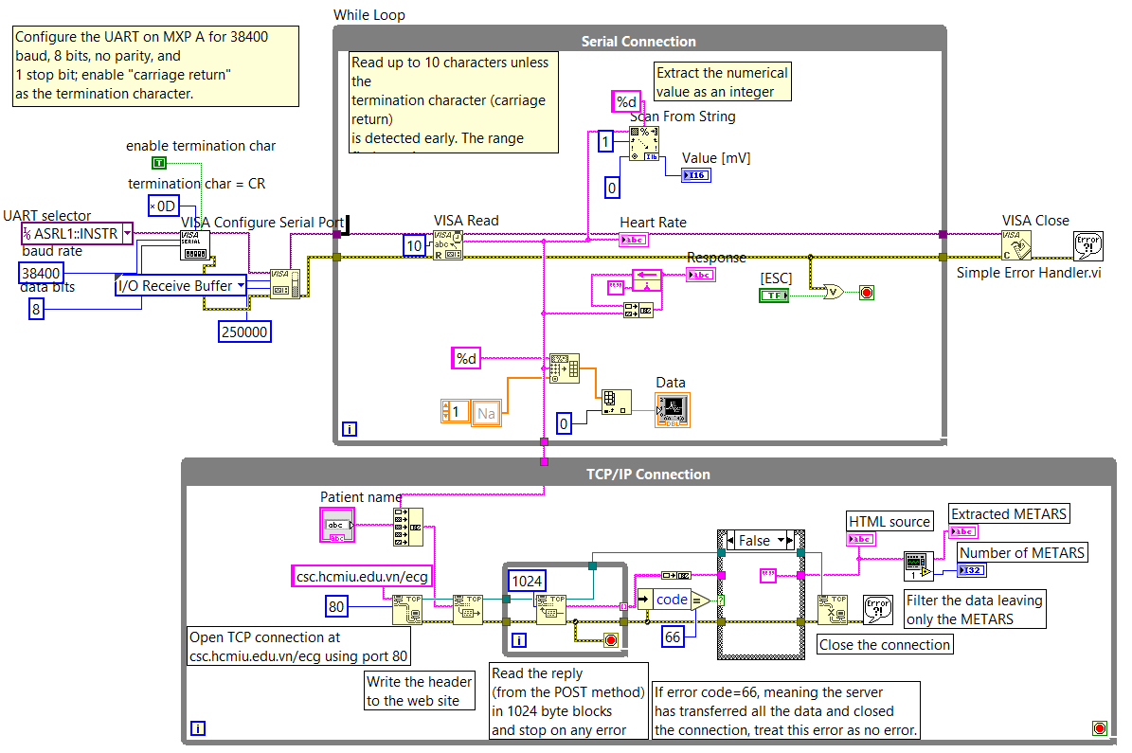

**Figure 9. Block diagram of NI Labview graphical user interface**

## Methods

1. *Baseline wander removal*

There is a bandpass filter with cut off frequencies [5 15] Hz compiled to the Arduino Nano in order to remove noise as well as base line wander from raw ECG signal before being transmitted to Android phone for further detection.

1. *Heart rate estimation*

In this method, any maxima of input signal that is greater than a defined threshold will be considered as an R peak by which RR interval and Heart rate are inferred. Brief description of the Thresholding method is illustrated by the flow chart shown in Fig. 5.

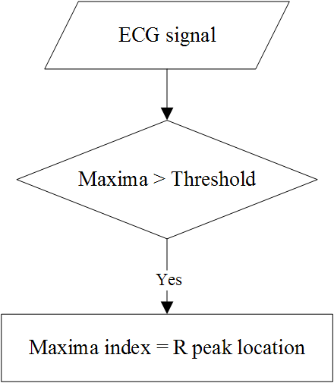

Figure 10. Thresholding method flow chart

In this project, we estimate the threshold by:

(1)

with:

max – maximum value of 1 second ECG segment

min – minimum value of 1 second ECG segment

and is updated after every one second.

RR interval and Heart rate are then calculated by equation (2) and (3).

(2)

(3)

with:

fs – sampling frequency

n – number of R peak detected in 1 second

Ri – location of the ith R peak

**6. Results and Discussion**

<This may include the challenges you faced, the solutions to your challenges, the  
benefits of using LabVIEW and NI tools, your plans to commercialize your product,  
and your project’s impact on social and environmental factors (for example, testing  
energy-saving light bulbs helps decrease costs and save energy).>  
<Please insert image(s) of the project with captions. Insert video links (if any) here.>

**Challenges and solutions**

In Cassandra project, we are currently using a smartphone as a mobile data hub, which helps us to connect the wECG with online database. For this reason, the smartphone is required to run continuously with 3G connection. This significantly reduces our product reliability. Therefore, in order to overcome this issue, we designed a stationary data hub, which will be installed in home or clinics. The hub replaces the smartphones to transmitted ECG data and manage the cardiovascular health of patients.

**Benefits of using LabVIEW and NI tools**

NI MyRIO kit is chose to build the data hub because of two reasons. First, the kit is powerful enough to receive and process signal in real-time, which is really important to this project. Second, the NI LabVIEW is a user-friendly design software with Graphical designing method, which allows us to design and implement within 3 months.

As we use Bluetooth protocol as the only wireless connection between wECG and the hub, the lack of this protocol on NI MyRIO is a critical problem. We overcame this by designing a Bluetooth adapter that is compatible with NI MyRIO. The system works well as the signals are smoothly transmitted from wECG to server.

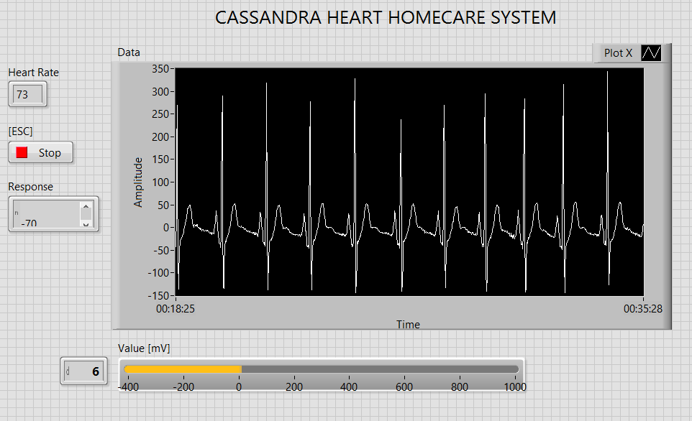

**Figure 12. LabVIEW graphical user interface**

**Commercialize plan <cần rút gọn>**

**7. Conclusion**

The result shows that the proposed Cassandra system can be used as that multi-signal monitoring for continuous ECG monitoring during daily activities. The wireless transceiver via BLE proved to be a potential choice due to its real-time transmission and low-power consumption. NI MyRIO shows its efficiency in signal processing. Furthermore, NI LabVIEW is an appropriate choice for. For future applications, Cassandra system with a wireless system is a potential solution for telemedicine, especially in heart diseases. This system gives patients and doctors chance to predict the occurrence of some dangerous diseases, such as arrhythmia or silent ischemia.